School bus stop arm law change social media for partners
Below are several sample social media posts for the recent school bus stop arm law change. The text below represents examples and suggestions. Partners are encouraged to create their own social media tailored for their audience.

Individualized posts and photos specific to your community are always preferred over premade graphics. Users may download pictures on the Office of Traffic Safety ShareFile.

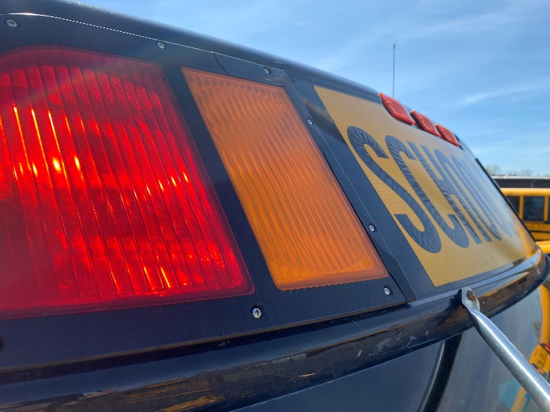
Suggested text: Heads up, drivers: Minnesota law on stopping for school buses has changed. You must now stop at least 20 feet from the bus whenever the red lights are flashing. The stop arm does not have to be extended. This update closes a loophole where drivers previously may have tried to “beat the arm” when passing a bus — a risky move that puts children in danger.

Slowing down and adding that extra caution will help make sure every child can travel to and from school safely.

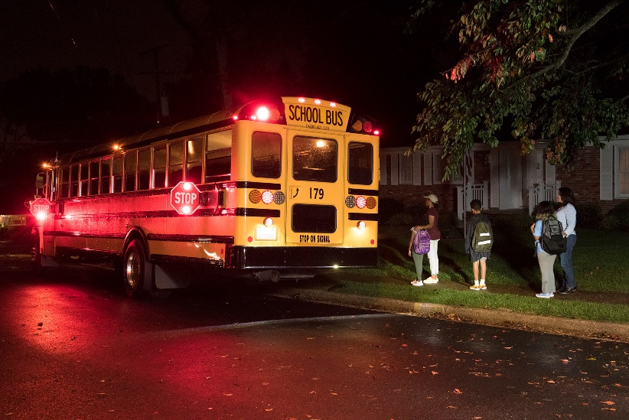
Suggested text: Need another reason to slow down and stop whenever you see flashing red lights on a school bus?
How about a $500 fine?
The school bus stop-arm law has been updated. Effective immediately, if you see flashing red lights on a school bus, you must stop at least 20 feet away. The stop arm does not have to be extended.
It’s a simple step that helps keep kids safe.

Across Minnesota, it’s a dangerous and all-too-common sight — a driver passing a school bus with red lights flashing as the stop arm extends.
Now, the law has changed. Making the rules clearer.
Drivers must stop at least 20 feet away when a bus has flashing red lights, even if the stop arm is not yet extended.
The first violation carries a $500 fine. More importantly, it puts children at risk.

School bus stop arm violation video montage: https://mndeptpublicsafety.sharefile.com/public/share/web-sd62dad7ef20741748a8e4dd75354515b

